**Assignment**: (Angular JS) - Assignment ID:06_Angular_Assignment2

Develop a single page crud application for posts using the restful web services

hosted at the below url:

https://jsonplaceholder.typicode.com/posts

Routes

GET /posts

GET /posts/1

POST /posts

PUT /posts/1

DELETE /posts/1

**Code**:



**Web Page Screenshots (Angular and Webservice)**:

**Listing View**

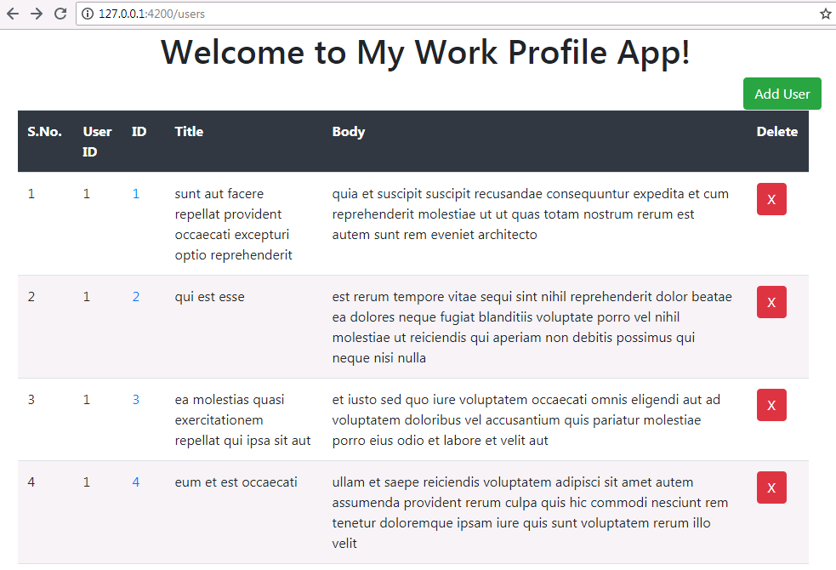

**Create Page**

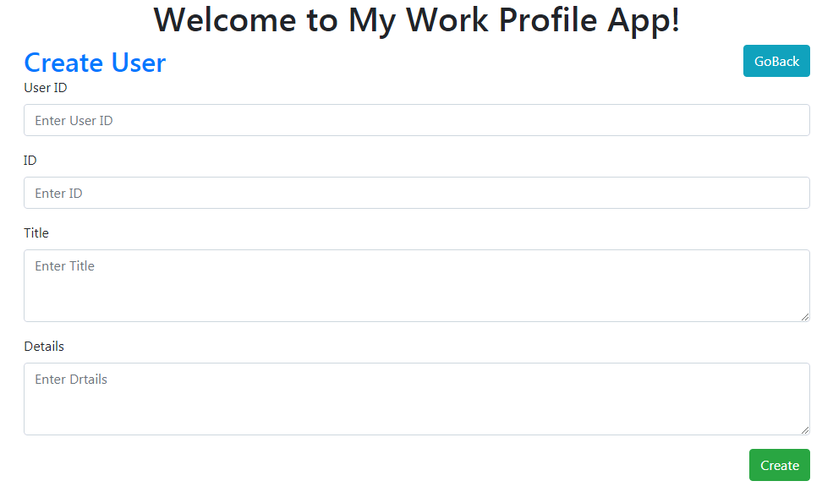

**Edit/Update Page**

